Exercise 3: Analog to digital converter.
This program (ADC.asm) is used to convert analog voltage (0-5 volts) to digital numbers (0-255). When running this program, by manually tuning the blue arrow shown in the Figure 3-1 from position 1 to position 3, analog voltage increases from 0 to 5 volts. As the voltage increases from 0 to 5 volts, the output of AD converter increases from 00000000 to 11111111 linearly, and is displayed by LEDs.

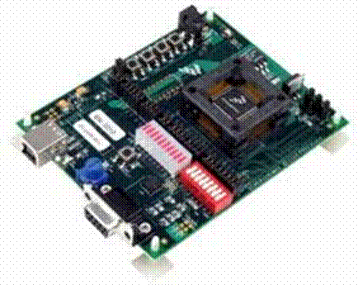
Figure 3-1, diagram showing the blue arrow adjusting analog voltage from 0 to 5 volts.
Blue arrow

Main section in the ADC program:
START_ADC
LDA #%00001000 ;Kick off a conversion
STA ADC1SC1 ;on ADC channel 8 (PTD0)
WAIT_ADC
TST ADC1SC1 ;Look at ADC status register
BPL WAIT_ADC ;Loop if ADC not finished conversion
;branch if (N) is 0

LDA ADC1RL ;Load data from ADC
STA PTFD ;Send to the LED bar

BRA START_ADC ;Repeat

Question:
Modify above section of the program to have the following output.

LED1
LED2
LED3
LED4
LED5
LED6
LED7
LED8
0 → 31
32 → 63
64 → 95
96 → 127
128 → 159
160 → 191
192 → 223
224 → 255

When the digital number ranges from 0 to 31, LED1 is lit, when the digital number ranges from 32 to 63, LED2 is lit, and so on.

Flowchart of the modification: (you may modify the program according to the following flowchart)
Start
A → D
Load digital to A
Is A less than 32?
Is A less than 63?
Is A less than 225?
Load digital to A
Load digital to A
2⁰ to LED
2¹ to LED
2⁷ to LED

